Milestone 5. Deployment
Now, the focus is on deploying the ComicCraft application on a local system using FastAPI. This involves configuring the server environment, installing all required dependencies, setting up static files and templates, and launching the app locally to simulate a real-world environment.
This milestone verifies that the complete comic generation workflow — including AI text generation, image creation, layout building, and PDF export — runs smoothly before planning deployment to a cloud platform in the future.

Activity 5.1: Preparing the Application for Local Deployment

Set up a virtual environment
Begin by creating a virtual environment to manage dependencies and ensure the deployment is isolated from other Python projects. Activate the environment and install all required libraries listed in the requirements.txt file, including FastAPI, Uvicorn, Google Generative AI, Hugging Face Diffusers, FPDF, and others.

python -m venv env
# For Windows
env\Scripts\activate
# For macOS/Linux
source env/bin/activate

pip install -r requirements.txt

Configure environment variables
- Use environment variables to store sensitive data such as the Gemini API Key and Hugging Face API token
- These variables can be set directly in the terminal or added to a .env file which is loaded into the application using python-dotenv.
GEMINI_API_KEY=your_gemini_api_key_here
HF_API_KEY=your-huggingface-api-key-here
Frontend-Backend Rendering via Jinja2
All user interactions are facilitated via Jinja2-rendered templates:
- index.html: Collects user inputs
- result.html: Displays the generated AI plan
- all_users.html: Lists all user records for admin view

Activity 5.2: Testing and Verifying Local Deployment

Start the FASTAPI Server
Navigate to the project root where your app/main.py file is located.
Use Uvicorn to launch the FastAPI development server with hot reload enabled:
uvicorn app.main:app --reload

Access the Application Locally
Once the server is running, open any web browser and navigate to:
http://127.0.0.1:8000

This URL loads the ComicCraft homepage, where users can input their story prompt, character name, setting, tone, and art style to generate a personalized AI-powered comic.
Additionally, the interactive API documentation provided by FastAPI can be accessed at:
http://127.0.0.1:8000/docs
This documentation allows developers to test available API endpoints, such as /generate-comic/json, /generate, /export-success, and /test-image.

Exploring Website’s web pages:

Home page:
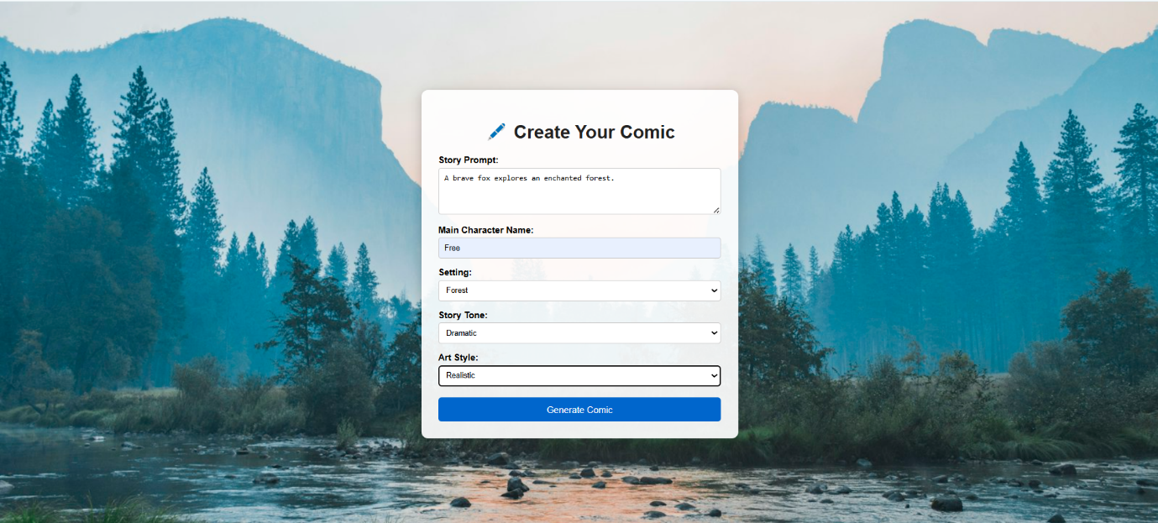
Description:
The homepage of ComicCraft is designed as an intuitive starting point for users to create AI-generated comic stories. It features a clean layout with a scenic background that fosters a creative atmosphere.
At the center, a structured form collects user inputs necessary for comic generation. Users can:
- Enter a Story Prompt describing their comic idea,
- Specify a Main Character Name,
- Choose a Setting (school, forest, space, city),
- Select a Story Tone (light-hearted, dramatic, poetic, funny),
- Pick an Art Style (anime, pixel art, comic book, realistic).
Once the form is submitted, the system uses AI models to automatically generate a complete comic, including storyline outlines, detailed dialogues, illustrations, and an exportable PDF.
The homepage is designed to be simple, user-friendly, and visually appealing, encouraging creativity and making the comic creation process accessible to all users without requiring technical expertise.
Comic Preview- Result page:

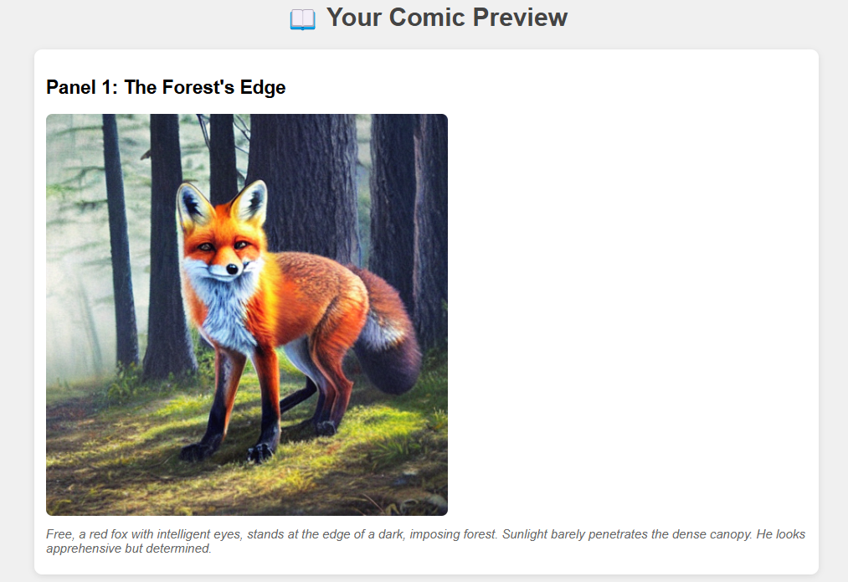

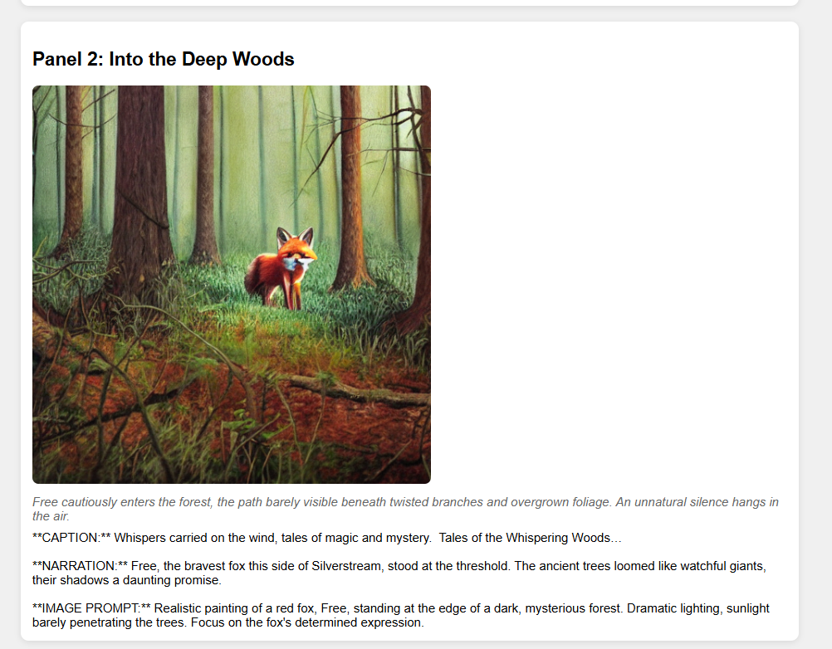

Description:
The Comic Preview Page in ComicCraft presents the AI-generated comic panels sequentially after the user submits their input through the homepage form. This page provides a complete view of the comic's storyline, combining visual and textual elements for each panel.
Each panel displayed on the page includes:
- Panel Title: Clearly labeled with the panel number and a descriptive title (e.g., "Panel 2: Into the Deep Woods").
- Comic Image: An AI-generated illustration created based on the scene's image prompt.
- Scene Description: A short descriptive paragraph, displayed in italics, that sets the atmosphere and context for the panel.
- Caption and Narration:
  - Caption providing a brief, ambient description of the environment or background sounds.
  - Narration detailing the main character's actions, emotions, or dialogue within the scene.
- Image Prompt Reference: The original artistic description used to generate the illustration, displayed for reference.
The design of the Comic Preview Page ensures that each panel is clearly separated and visually appealing, making it easy for users to follow the story’s flow panel-by-panel.
The combination of imagery, scene-setting description, and narrative text helps create an immersive storytelling experience directly from the AI-generated content.
At this stage, the page focuses purely on comic viewing and story review, allowing users to experience the full creative output before proceeding to any final actions like exporting.
Download Button:


Description:
On the Comic Preview Page, a "Download Your Comic as PDF" button is displayed.
When users click this button, the entire comic — including images, panel titles, scene descriptions, captions, and narration — is compiled into a professionally formatted PDF file and downloaded directly to the user's device.
This ensures users can save, share, and view their comic offline.

Comic Export Success Page:
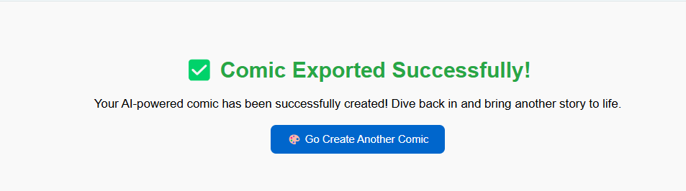
Description:
After the download is triggered, users are automatically redirected to the Comic Export Success Page. This page provides a confirmation message indicating that their AI-powered comic has been successfully created and downloaded. The success page also includes a call-to-action button, "Go Create Another Comic", which encourages users to return to the homepage and start a new comic creation process.
The export and success flow are designed to provide closure and satisfaction after the creative process, ensuring users have a tangible output from their story idea while promoting continued engagement with the platform.

